U019
Unbuilt K-12 School
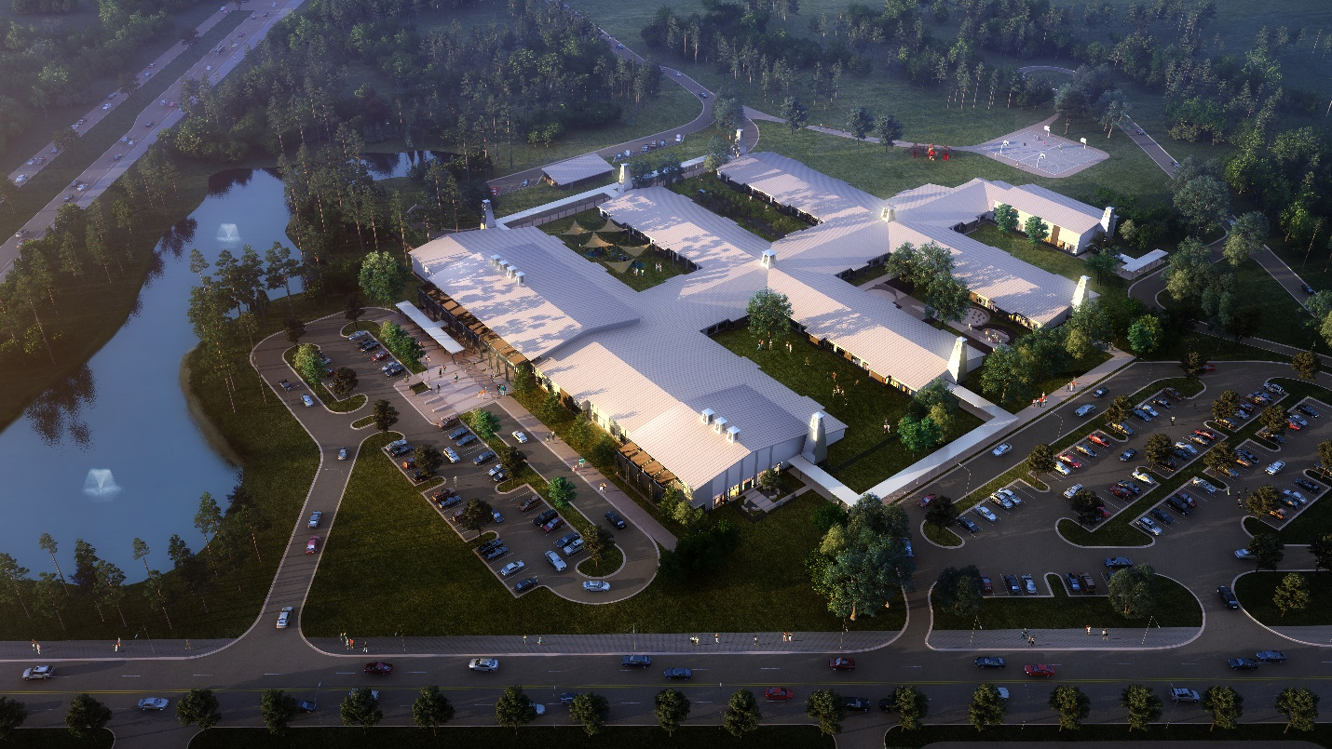

The coastal community that this new elementary school will serve is comprised of several upscale new urbanist beach towns, with a population that not only appreciates good design but demands a higher level of aesthetics. By integrating some of the features common to the local architectural vernacular, the new school will be tied to its very special community.

The use of architectural elements such as towers, monitors, and cupolas reinforce the civic presence of the school and provide a focus on the entry experience and school as destination. At night, the towers take on a whole new quality - highlighting the school as a glowing beacon and giving it a greater civic presence. Monitors are used to bring floods of natural light into the interior of hallways, with one monitor above each intersection of 4 classroom modules.

Because daylighting in educational spaces has been proven to improve test scores, enhance interest, and aid in developing cognitive abilities, each classroom will have views to the outdoors, and roof overhangs and shading devices will be employed to control glare and mitigate solar heat gain. Two major elements of the façade – the cafetorium and media center – will be higher and feature brise-soleils for sun shading. While stucco and cast stone are used on the exterior, a brick datum extending to the bottom of the windows serves as a base and reduces potential staining.

The overall objective was to provide a flexible, state-of-the-art facility that emphasizes “anytime learning” in a healthy, light-filled environment that contributes to the students’ well-being and future success. Because the students in a K-5 school mature at widely different rates, the district wanted separate classroom wings for each grade group. The resulting plan has efficient, double-loaded corridors, and each classroom enjoys views to the outdoors and to the courtyards created by the wings. Activity zones are provided at intersections where light monitors bring in natural daylight, and stepped seating, teaching walls, and interactive wall elements provide additional “anytime learning” areas.

A basic teaching module consists of 2 classrooms, a shared learning space, storage and teacher planning area, and single unisex toilet rooms. The restrooms in each classroom eliminate the need for students to be unsupervised in hallways or gang restrooms, and reduces the potential for bullying.

The design incorporates access to nature for every child, and provides outdoor collaboration opportunities for interaction in the light and air of the temperate local climate. Courtyards, outdoor reading risers, a wetland nature walk, and a community garden will help students to learn firsthand about their unique environment. As part of the Green Globes sustainability initiative, native landscaping will minimize the need for irrigation and increase habitat for indigenous fauna. Each classroom zone will be branded with a particular animal, flora, and ecosystem, giving students in each grade level grouping a sense of community within the school, and assisting in wayfinding.

