EI013
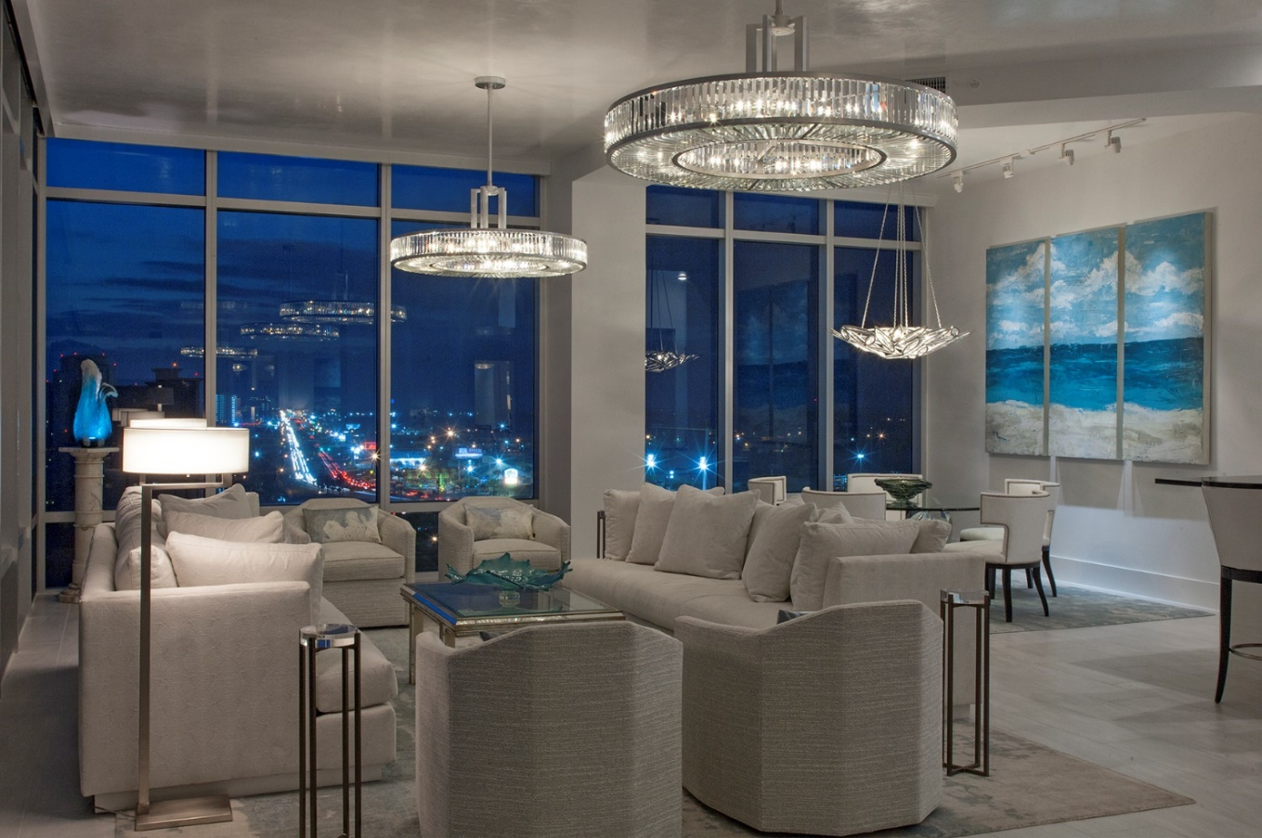

Gulf Front Penthouse Remodel

This unit was purchased as a home away from home where the owner and their guests could enjoy the beauty of the beach without giving up the comforts they desired. The location and view potential were key features to the owner but they felt it was too dark and cut up.
Most of the renovation focused on enlarging the living area and raising the ceilings as much as possible to create a wider and taller view. Color and texture were critical elements used to brighten and update the interior. Every effort was made to reflect light into the unit.
The Mechanical ductwork was rerouted to raise the soffits in the kitchen and living area. In a bold move, it was determined the existing bar and master bedroom would be demolished to create larger living room and more expansive views.

